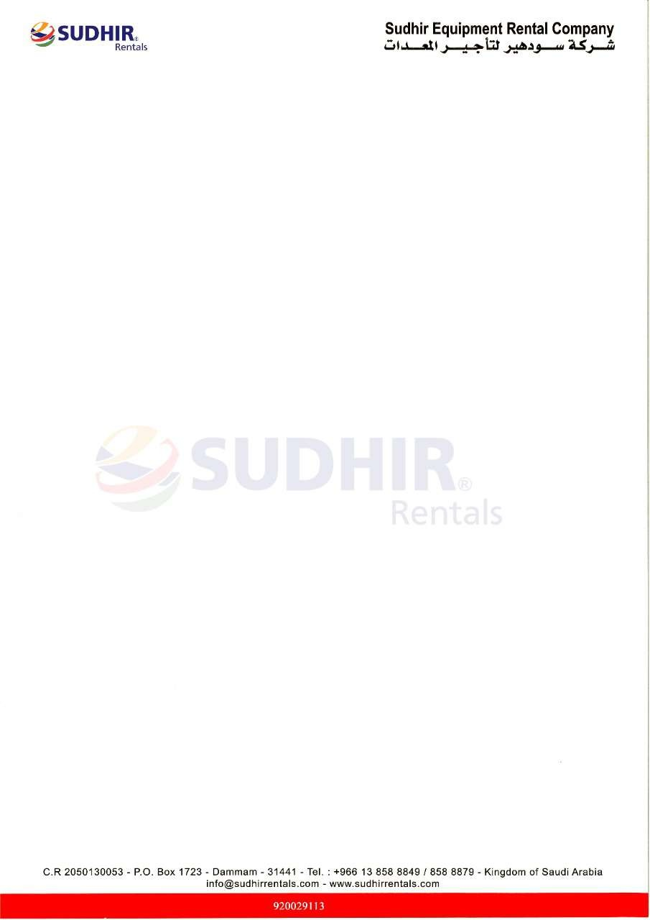

Ownership Certificate
To Whom It May Concern
This is to certify that the following equipment mentioned below are the sole owned by Sudhir Equipment Rental Company.

Equipment | Boom Lift
Brand / Make | JLG
Asset ID | S28SJ-679
Model Number | 860SJ
Serial Number | B300014685
Working Height | 28 Meter
Type | Telescopic
Manufacturing Year | 2022

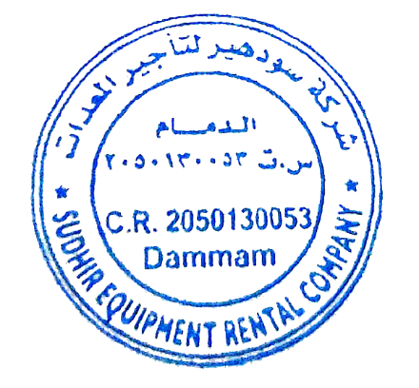
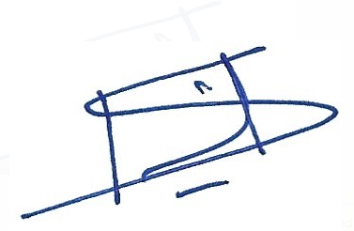

Authorized Signature
Branch Manager
Sudhir Equipment Rental Company
Kingdom of Saudi Arabia

